Section A

Answer all questions in this section in the spaces provided.

1 |  | A sample of solid iron(II) ethanedioate, FeC₂O₄ was dissolved in 20 cm³ of 1.0 mol dm⁻³ H₂SO₄. The solution was transferred to a 250 cm³ standard flask and made up to the mark with deionised water. 25.0 cm³ of this solution was pipetted and titrated against acidified aqueous potassium manganate(VII). It was found that 25.40 cm³ of 0.0500 mol dm⁻³ solution of potassium manganate(VII) was required for complete reaction.  In this reaction the manganate(VII) ions undergo the following change:  MnO₄⁻(aq) + 8H⁺(aq) + 5e⁻ → Mn²⁺(aq) + 4H₂O(l)
 |  | (a) |  | Both Fe²⁺ and C₂O₄²⁻ are oxidised by MnO₄⁻ in the above reaction. The half-equation for the oxidation of Fe²⁺ is given below.  Fe²⁺(aq) → Fe³⁺(aq) + e⁻  Write a half-equation to show the oxidation of C₂O₄²⁻ to CO₂.
 |  |  |  | ● C₂O₄²⁻ → 2CO₂ + 2e⁻
 |  |  |  | [1]
 |  | (b) |  | Hence, write a balanced ionic equation for the reaction between iron(II) ethanedioate and acidified potassium manganate(VII).
Reduction: MnO₄⁻ + 8H⁺ + 5e → Mn²⁺ + 4H₂O x 3
Oxidation: Fe²⁺ → Fe³⁺ + e⁻
x 5
C₂O₄²⁻ → 2CO₂ + 2e⁻

Number of electrons gained = Number of electrons lost

● 5Fe²⁺ + 5C₂O₄²⁻ + 3MnO₄⁻ + 24H⁺ → 5Fe³⁺ + 10CO₂ + 3Mn²⁺ +12H₂O

5FeC₂O₄ + 3MnO₄⁻ + 24H⁺ → 5Fe³⁺ + 10CO₂ + 3Mn²⁺ +12H₂O

 |  |  |  |  |  | [1]
 |  | (c) |  | Calculate the amount of MnO₄⁻ needed for the reaction.
● Amount of MnO₄⁻ needed for reaction = 25.40/1000 x 0.0500
= 1.27 x 10⁻³ mol

[1]

 |  | (d) |  | Hence, calculate the concentration of iron(II) ethanedioate solution in the standard flask.
● Amount of FeC₂O₄ in 25.0 cm³ = 1.27 x 10⁻³ x 5/3 (5FeC₂O₄ ≡ 3MnO₄⁻)
= 2.12 x 10⁻³ mol

● Concentration of FeC₂O₄ in the standard flask = 2.12 x 10⁻³ / (25.0/1000)
= 0.0848 mol dm⁻³
 |  |  |  | [2]
 |  | (e) |  | Determine the mass of iron(II) ethanedioate in the sample.
● Amount of FeC₂O₄ in 250 cm³ = 2.12 x 10⁻³ x (250/25)
= 0.0212 mol

● Mass of FeC₂O₄ in the sample = 0.0212 x (55.8 + 12.0 x 2 + 4 x 16.0)
= 3.05 g

 |  |  |  |  |  | [2]
 |  |  |  |  |  | [Total: 7]
 | 2 |  | 0.05 mol of ethyne, C₂H₂, is added to 0.15 mol of O₂ in a reaction vessel. The vessel is immersed in a thermostat at 125ºC, and the volume of gas within the vessel is read continuously. At time A, the mixture is sparked, whereupon the C₂H₂ and O₂ react accordingly to the equation  C₂H₂ + O₂ → 2CO₂ + H₂O.  At time C, 4 g of solid sodium hydroxide is introduced into the vessel. The variation in volume during this time is represented in the following graph.  Time/min  A  B  C  Volume of Gas  0 10  D  At constant temperature of 125ºC
 |  |  | (a) |  | (i) |  | Draw a dot-and-cross diagram of ethyne, C₂H₂.
 |  |  |  |  |  |  | ●
 |  |  |  |  | (ii) |  | State the number of sigma and pi bonds in C₂H₂.
 |  |  |  |  |  |  | ● sigma bond(s): 3 pi bond(s): 2
 |  |  |  |  | (iii) |  | Explain the difference in the formation of sigma bonds and pi bonds, in terms of orbital overlap.
● Sigma bond is formed from a head-on overlap of the hybridized sp orbitals
● while the pi bond is formed from the sideways overlap of p orbitals.
 |  |  |  |  |  |  | [4]
 |  |  | (b) |  | (i) |  | Define standard enthalpy change of combustion.
 |  |  |  |  |  |  | ● Standard enthalpy change of combustion is the heat evolved when 1 mole of substance is completely burnt in oxygen at 298K and 1atm.
 |  |  |  |  | (ii) |  | Using the Data Booklet, calculate the enthalpy change of combustion of C₂H₂.

H-C≡C-H + O=O → 2 O=C=O + H-O-H

●

Bonds broken: C-H, 1 C≡C, O=O ➔ 2(410) + 840 + (496) = 2900 kJmol⁻¹

Bonds formed: 4 O=C, 2 O-H ➔ 4 (740) + 2 (460) = 3880 kJmol⁻¹

● Enthalpy change of combustion of C₂H₂ = + 2900 – 3880 = - 980 kJmol⁻¹

 |  |  |  |  |  |  | [3]
 |  |  | (c) |  | (i) |  | State the gas or gases remaining in the vessel at the 10 min mark.
 |  |  |  |  |  |  | ● CO₂ , O₂ and H₂O
 |  |  |  |  | (ii) |  | Calculate the number of moles of each gas present.
C₂H₂ ≡ 2 CO₂
No of moles of CO₂ formed = 0.05 x 2 = 0.100 mol

●● No of moles of O₂ left unreacted = 0.15 – (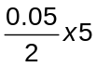) = 0.0250 mol
No of moles of H₂O = 0.0500 mol

 |  |  |  |  | (iii) |  | The volume of gas between time B and C is less that the initial value at time A. Calculate this difference in volume.  Assume one mole of gas occupies 33 dm³ at the given temperature and pressure.
No of moles of gas before combustion = 0.05 + 0.15 = 0.200 mol
No of moles of gas after combustion = 0.100 + 0.025 + 0.05 = 0.175 mol

● Difference in volume = (0.200 – 0.175) x 33 = 0.825 dm³

 |  |  |  |  |  |  | [4]
 |  |  |  |  | (d) |  | Write an equation to explain the effect of the addition solid sodium hydroxide at time C.
 |  |  |  |  |  |  | ● 2NaOH + CO₂ → Na₂CO₃ + H₂O
 |  |  |  |  |  |  | [1]
 |  |  |  |  |  |  | [Total: 12]
 | 3 |  | Butane is often added to regular gasoline to boost performance without creating a highly volatile product. Other applications include its use as an appliance fuel, in air conditioning, refrigeration and industrial furnaces. This question is about butane and its derivatives.
 |  |  | (a) |  | (i) |  | The diagram below shows an energy cycle involving the fuel butane. Use the following data to calculate the enthalpy change of combustion, ΔH_{c}, of liquid butane.  ΔH_{f} (liquid butane) = -148 kJ mol⁻¹  ΔH_{f} (water) = -286 kJ mol⁻¹  ΔH_{f} (carbon dioxide gas) = -394 kJ mol⁻¹  ΔH_{c}º  CH₃CH₂CH₂CH₃(l) + 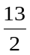O₂(g) 4CO₂(g) + 5H₂O(l)  ΔH_{c}  ΔH₁  ΔH₂  4C(s) + 5H₂(g) + 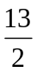O₂(g)
Using Hess’ Law, ΔH₁ = ΔH₂ + ΔH_{c}

● ΔH_{c} = 4(-394) + 5(-286) – (-148) = -2.86 x 10³ kJ mol⁻¹

 |  |  |  |  | (ii) |  | Chemical companies manufacture containers filled with liquid butane for use by campers. A camper found a left-over container of butane and estimates that there was about 10 g of liquid butane left.  Using your answer in (a)(i), calculate the mass of water, at an initial temperature of 25ºC, that could be brought to the boiling point by burning this butane.  Assume that the specific heat capacity of water is 4.18 J g⁻¹K⁻¹.
● Total heat produced by burning 10 g butane = 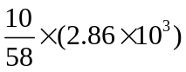
= 493 kJ
● q = mcΔT
493 x 1000 = m x 4.18 x (100 – 25)
m = 1573 g = 1.57 kg water
 |  |  |  |  |  |  | [3]
 |  |  | (b) |  | Propanoic acid can be synthesized from butane by a 3-step reaction sequence shown below.  step 1 hot ethanolic KOH step 3  butane D E propanoic acid
 |  |  |  |  | (i) |  | Suggest the reagents and conditions used for steps 1 and 3 in this synthesis and give the structural formulae of compounds D and E.
 |  |  |  |  |  |  | ● step 1: Cl₂ gas, uv light
 |  |  |  |  |  |  | ● step 3: acidified KMnO₄, heat
● D: 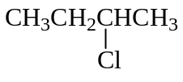or CH₃CH₂CH₂CH₂Cl

● E: CH₃CH₂CH=CH₂
 |  |  |  |  | (ii) |  | Name the type of reaction for step 1.
 |  |  |  |  |  |  | ● Free radical substitution
 |  |  |  |  |  |  | [5]
 |  |  | (c) |  | Butenedioic acid has the structural formula HO₂CHC=CHCO₂H.
 |  |  |  |  | (i) |  | Explain why butenedioic acid exhibits geometric isomerism.
 |  |  |  |  |  |  | ● It has restricted rotation about C=C bond and there are 2 different substituents bonded to each C atom of the C=C bond.
 |  |  |  |  | (ii) |  | Draw the structural formulae of the geometric isomers of butenedioic acid.
●
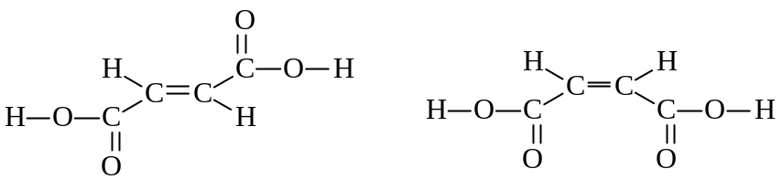

 |  |  |  |  | (iii) |  | Butane is the feedstock for DuPont's catalytic process for the preparation of maleic anhydride which can then be converted into cis-butenedioic acid.  Explain why trans-butenedioic acid has a higher boiling point than cis-butenedioic acid.
● The cis isomer can form intramolecular hydrogen bonds due to close proximity of the two - CO₂H groups and forms less extensive intermolecular hydrogen bonds
● The trans isomer only forms intermolecular hydrogen bonding. More energy required to break the more extensive intermolecular hydrogen bonding of trans isomer, so it has higher boiling point.
 |  |  |  |  |  |  | [4]
 |  |  |  |  |  |  | [Total: 12]
 | 4 |  | Consider the following reaction scheme involving CH₂=C(CH₃)CHO:  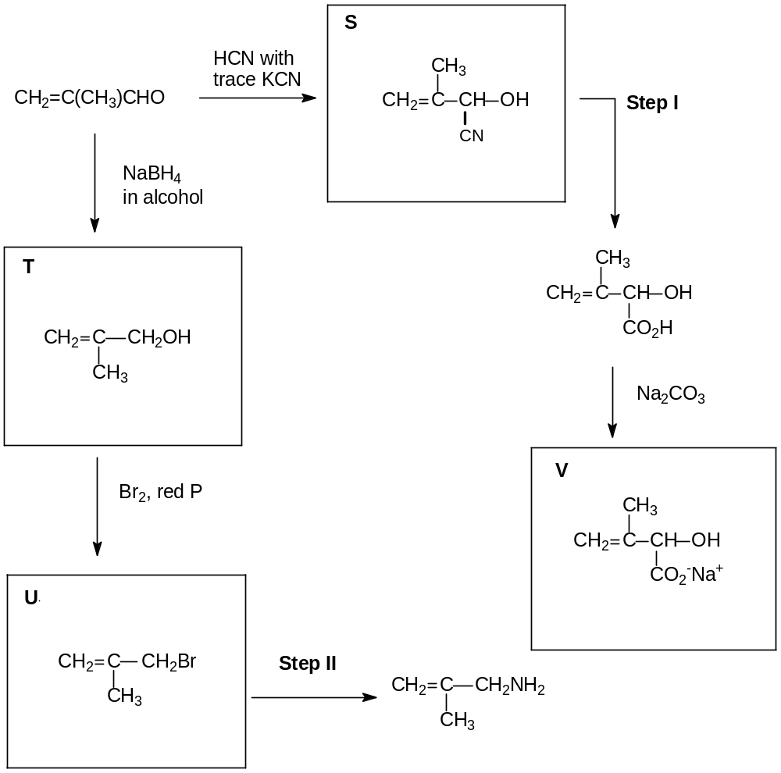  PBr₃
 |  |  | (a) |  | Draw the structural formulae for organic compounds S, T, U and V in the boxes above.
 |  |  |  |  |  |  | [4]
 |  |  | (b) |  | Suggest reagents and conditions for steps I and II.
 |  |  |  |  | ● step I: dilute acid, heat
 |  |  |  |  | ● step II: conc NH₃ in ethanol, heat in sealed tube
 |  |  |  |  |  |  | [2]
 |  |  | (c) |  | Describe a simple chemical test to distinguish CH₂=C(CH₃)CHO and compound W which has the following structure:  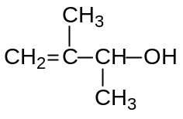  Write a balanced equation for the reaction involved.
 |  |  |  |  | ● Add PCl₅ to each sample of CH₂=C(CH₃)CHO and W.
 |  |  |  |  | ● W will give white fumes of HCl while no fumes is observed for CH₂=C(CH₃)CHO.
 |  |  |  |  | ● + PCl₅ 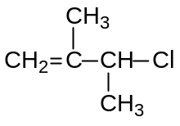+ POCl₃ + HCl
Other possible tests:
- Tollens’ Test
- Fehling’s Test
- Na metal
 |  |  |  |  |  |  | [3]
 |  |  |  |  | [Total: 9]

Section B (Essay Questions)

Answer 2 out of 3 questions. Begin each answer on a separate sheet of paper.

5 | (a) | At a crime scene, preliminary investigations led the homicide detectives to believe that concentrated sulfuric acid was used to hurt the victim.  Some samples of blood and fibres were also collected from the victim and sent to the forensic laboratory. Upon analysis, the fibres were found to contain oxides of Q and R.  Q and R are elements in period 3 of the Periodic Table and the following are known for their oxides:  ● Oxide of Q has a melting point of 1275ºC and it dissolves readily in water. It is a good conductor of electricity in molten state.  ● Oxide of R has a melting point of 1830ºC and it does not dissolve in water. It is a non-conductor of electricity.
 |  | (i) |  | Identify the two oxides.
● Oxide of Q: Na₂O
● Oxide of R: SiO₂
 |  | (ii) |  | Write an equation, with state symbols, for the reaction of oxide of Q with water. Give the approximate pH of the resulting solution formed. What is the effect of adding universal indicator to the solution?
● Na₂O(s) + H₂O(l) 2 NaOH(aq)
● pH = 13
● Universal Indicator turns violet / indigo.
 |  | (iii) |  | Relate the melting points of the two oxides to their structures and bonding.
● Oxide of Q has giant ionic structure and melting involves breaking strong ionic bonds. A large amount of energy is required, hence a high melting point.
● Oxide of R has giant covalent structure and melting involves breaking strong covalent bonds. A large amount of energy is required, hence it also has a high melting point.
 |  | (iv) |  | State and explain the variation in the maximum oxidation number of the elements sodium to sulfur in their oxides.
● The oxidation number of period 3 elements in their oxides increases from +1 for Na to +6 for S.
● The maximum oxidation number corresponds to the maximum number of valence electrons that can be used for bonding with oxygen. It is positive because oxygen is more electronegative than the elements.

Concentrated sulfuric acid is commonly used in esterification reactions:

CH₃CH₂CH₂OH(l) + CH₃CO₂H(l) CH₃CO₂CH₂CH₂CH₃(l) + H₂O(l) ∆H

 |  | (v) |  | Draw and name the shape of sulfuric acid molecule with respect to sulfur atom, stating its bond angle.
●

● Shape and bond angle: tetrahedral, 109.5º
 |  | (vi) |  | A student intern at the forensic laboratory made the following claim: For the esterification reaction above, the enthalpy change, ∆H, is known as the enthalpy change of neutralisation. However, ∆H cannot be calculated by using only the bond energies in the Data Booklet.  Comment on the intern’s claim.
● The first sentence of the intern’s claim is incorrect. Esterification reaction is not a neutralisation reaction. (Esterification is an example of condensation reaction.)
● The second sentence is correct. The bond energies in the Data Booklet cannot be used directly to calculate ∆H as the reactants and products are not in the gaseous phase.
 |  | (vii) |  | Suggest how propan-1-ol can be formed from 3-chloropropanal in 2 steps. Draw the structure of the intermediate that is formed. | [16]
● Step I: NaOH in ethanol, heat or reflux
● Step II: H₂ with Nickel, elevated temperature and pressure
● Intermediate:
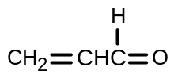
 | (b) | The melting points of gallium oxide, Ga₂O₃, and arsenic pentoxide, As₂O₅, are 1795ºC and 315ºC respectively. By considering the likely structure and bonding of each of these oxides, write balanced equations for the reactions, if any, of each of these oxides with  - NaOH(aq)  - HCl(aq). |  |  | [4]
● Ga₂O₃ reacts with NaOH(aq):
Ga₂O₃ + 2NaOH + 3H₂O → 2NaGa(OH)₄
● Ga₂O₃ reacts with HCl(aq): Ga₂O₃ + 6HCl → 2GaCl₃ + 3H₂O
● As₂O₅ reacts with NaOH(aq): As₂O₅ + 6NaOH → 2Na₃AsO₄ + 3H₂O
● As₂O₅ does not react with HCl(aq).
 |  |  | [Total: 20]

6 | Chlorine was first prepared in pure form by the Swedish chemist Carl Wilhelm Scheele in 1774. Being a very reactive element, chlorine is always found in compounds. It can be found dissolved in seas, salty lakes and in the ground as rock salts or halite. This question is about chlorine-containing compounds which are widely used in industrial, agricultural and medical fields.
 | (a) | Describe and explain the reactions, if any, of the chlorides of the elements sodium, aluminium and phosphorus with water, relating these reactions to the bonding of the chlorides. Give the approximate pH of any solutions formed and write equations where appropriate. |  | [6]
- NaCl is ionic in nature. Only hydration take place.
NaCl (s) → Na⁺ (aq) + Cl⁻ (aq) pH = 7
- AlCl₃ is covalent in nature. Both hydration and hydrolysis take place as Al³⁺ has high charge density and a high polarizing power. It draws electrons away from surrounding water molecules and weakens the O-H bond. It is easier for H⁺ ion to leave the water molecule.
- both equations: AlCl₃(s) + 6H₂O(l) → [Al(H₂O)₆]³⁺(aq) + 3Cl⁻(aq)
[Al(H₂O)₆]³⁺(aq) [Al(H₂O)₅OH]²⁺(aq) + H⁺(aq)
OR combine both equations
AlCl₃(s) + 6H₂O(l) [Al(H₂O)₅OH]²⁺ + 2Cl⁻(aq) + H⁺(aq) pH = 3
- PCl₅ is covalent in nature. Hydrolysis occurs due to the presence of energetically accessible vacant 3d orbitals in P for dative bonding with water.
- PCl₅(s) + 4H₂O(l) → H₃PO₄(aq) + 5HCl (aq) pH = 1 - 2
• all pH values are correct

 | (b) | 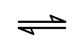  Under equilibrium conditions, 98 cm³ of Cl₂ gas dissolves in 100 cm³ of water at room temperature and pressure. The equilibrium set up is as follows:  Cl₂(aq) + H₂O(l) Cl⁻(aq) + HClO(aq) + H⁺(aq)
 |  | (i) | Calculate the equilibrium concentration of Cl₂ in mol dm⁻³.
No of moles of Cl₂ gas = 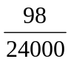= 4.08 x 10⁻³ mol
- concentration of Cl₂ in a saturated solution
= 4.08 x 10⁻³ x 1000/100 = 4.08 x 10⁻² mol dm⁻³
 |  | (ii) | Write an expression for the equilibrium constant, K_{c}, of this reaction.
 |  |  | ● K_{c} =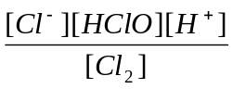
 |  | (iii) | Given that the numerical value of the equilibrium constant for this reaction is 4.7 x 10⁻⁴ and using your answer in (b)(i), calculate the equilibrium concentration of H⁺(aq) and hence pH of the solution.
Let the equilibrium concentration of H⁺(aq) be x moldm⁻³.
K_{c} = 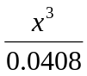= 4.7 x 10⁻⁴
● x = 2.68 x 10⁻² mol dm⁻³ = equilibrium concentration of H⁺(aq)
● pH = - lg 2.68 x 10⁻² = 1.57
 |  | (iv) | Predict and explain the change in pH (if any) when aqueous silver nitrate is added the above solution. | [6]
- When aqueous silver nitrate is added, the Ag⁺(aq) and Cl⁻(aq) forms a white ppt of silver chloride thus decreasing [Cl⁻]. By Le Chatelier’s Principle, the system tries to counteract the decrease in [Cl⁻] by shifting position of equilibrium to the right.
- At new equilibrium, the [H⁺] increases. pH decreases.
 | (c) | Compound C, C₅H₁₀Cl₂, reacts with hot aqueous potassium hydroxide to produce compound D. Oxidation of D gives compound E which does not react with Tollens’ reagent. 1 mole of compound E reacts with 2 moles of 2,4-dinitrophenylhydrazine to give an orange precipitate. Both D and E react with hot alkaline aqueous iodine to give a yellow precipitate.  When C reacts with hot ethanolic KOH, a different compound F is formed. F reacts with hot acidified potassium manganate to give HO₂C-CH₂-CO₂H and 2 moles of CO₂ as products.  Identify and draw the structural formulae of compounds C, D, E, F and explain the reactions described. |  | [8]
 |  | [Total: 20]
- C, C₅H₁₂Cl₂ is a halogenoalkane that undergoes nucleophilic substitution with hot aq KOH to give D which is a diol.
- E does not react with Tollen’s reagent so E could be a diketone, not di-aldehyde.
- E reacts with 2,4-dintrophenylhydrazine to give an orange ppt, so this confirms E is diketone.
- Since D is oxidized to give E which is a diketone, D is a secondary alcohol with 2 –OH groups.
- Since both D and E react with alkaline aqueous iodine to give a yellow ppt, E has 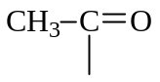group has D has the structure 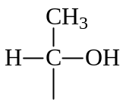
- C undergoes elimination with hot ethanolic KOH to form F which is an alkene.
- Since strong oxidation of F by hot acidified potassium manganate gives HO₂C-CH₂-CO₂H and 2 moles of CO₂ as products, F is a terminal diene with two C=CH₂ groups
- F is H₂C=CH-CH₂-CH=CH₂.
- C is 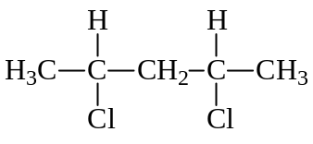
- D is 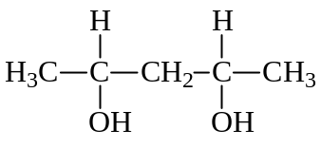
● E is 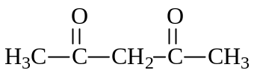
[8 + 3 bonus]

7 | This question is on acids and bases.
 | Ethanoic acid, CH₃COOH is a weak acid which is responsible for the sour taste and pungent smell of vinegar.
 | (a) | Write the equation for the dissociation of CH₃COOH in water. |  |  |  | [1]
 |  | • CH₃COOH + H₂O CH₃COO⁻ + H₃O⁺
 | (b) | It is found that the pH of CH₃COOH is 2.88. Determine the percentage of 0.01 mol dm⁻³ of CH₃COOH that has dissociated in water. |  |  |  | [2]
pH = -lg[H⁺]
• [H⁺] = 10^{-2.88}
= 1.32 x 10⁻³ mol dm⁻³

• Percentage of ethanoic acid that has dissociated in water
= (1.32 x 10⁻³/ 0.01) x 100 %
= 13.2 %
 | (c) | In an experiment, 20 cm³ of 0.01 mol dm⁻³ aqueous ethanoic acid was added to 10 cm³ of 0.01 mol dm⁻³ sodium hydroxide.
 |  | (i) |  | Write a balanced equation for the above reaction.
 |  |  |  | • CH₃COOH + NaOH → CH₃COO⁻Na⁺ + H₂O
 |  | (ii) |  | Explain, with the aid of two equations, how the solution formed in the experiment can control pH upon addition of small amounts of H⁺ and OH⁻. |  | [4]
Solution (c) is a buffer solution which is made up of CH₃COOH and CH₃COO⁻Na⁺.

• CH₃COO⁻ + H⁺ → CH₃COOH
When a small amount of acid is added, CH₃CO₂⁻ mainly from the salt neutralizes the acid added and there is negligible change in pH.

• CH₃COOH + OH⁻ → CH₃COO⁻ + H₂O
When a small amount of base is added, CH₃CO₂H neutralizes the base added and there is negligible change in pH.

• 1 mark for explanation
 | (d) | A bromoalkane, 2-bromo-2-methylpropane, (CH₃)₃CBr is hydrolysed by excess aqueous sodium hydroxide.
 |  | (i) |  | Write a balanced equation for the reaction.
 |  |  |  | • (CH₃)₃CBr + NaOH → (CH₃)₃COH + NaBr
The following results were obtained from an experiment on the above hydrolysis.

time/min | [(CH₃)₃CBr]/mol dm⁻³
0 | 0.200
25 | 0.152
50 | 0.115
75 | 0.088
100 | 0.067
125 | 0.051

 |  | (ii) | Plot the data on suitable axes and use your graph to deduce the order of the reaction with respect to (CH₃)₃CBr.
•• Labelled axes, points plotted correctly and smooth curve
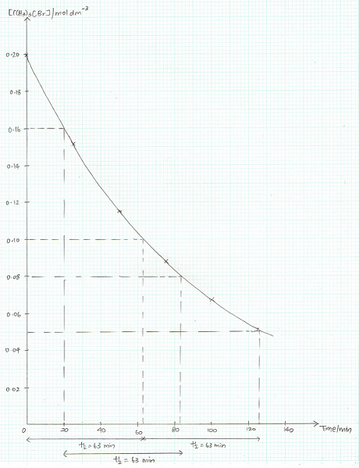
• From the graph, half-life is constant at 63 minutes (need to show 2 half-lives on the graph),
• thus first order with respect to (CH₃)₃Br

 |  | (iii) | Given that the same graph was obtained when the experiment was repeated with the concentration of aqueous sodium hydroxide being doubled, deduce the order of reaction with respect to sodium hydroxide.  Hence construct a rate equation for the reaction.
• Rate of reaction does not change when concentration of aqueous sodium hydroxide is doubled, thus the order of reaction with respect to OH⁻ is zero.

• Rate = k[(CH₃)₃CBr]

 |  | (iv) | State how the half-life of the reaction is affected when the experiment is repeated with the concentration of (CH₃)₃CBr doubled.
 |  |  | • The half-life remains unchanged. (For a 1st order reaction, the half-life, t_{½}, is a constant and is independent of the initial concentration of reactant in which half-life is measured.)
 |  | (v) | In another experiment conducted using aqueous NaOH, (CH₃)₃CCl was used instead of (CH₃)₃CBr. With the aid of the Data Booklet, state how you would expect the rate of this reaction to compare to that of the reaction of (CH₃)₃CBr with aqueous NaOH. Explain your answer.
• The rate of reaction for (CH₃)₃CCl with aqueous NaOH would be slower than that for (CH₃)₃CBr.
• From the Data Booklet, bond energy of C-Cl = 340 kJ mol⁻¹ and bond energy of C-Br = 280 kJ mol⁻¹. Thus more energy is required to break the stronger C-Cl bond, resulting in a slower rate of reaction.
(Nucleophilic substitution reaction of RX involves the breaking of the C-X bond.)
 |  | (vi) | Suggest how 2-bromo-2-methylpropane can be synthesised from 2-methylpropan-1-ol, CH₃CH(CH₃)CH₂OH. |  |  | [13]
CH₃CH(CH₃)CH₂OH

• excess concentrated H₂SO₄, 180 ºC
OR Al₂O₃, 400 ºC
• (CH₃)₂C=CH₂

• HBr(g) or HBr dissolved in CCl₄ at room temperature

(CH₃)₃CBr

 |  |  | [Total: 20]

